MindEase – Mental Health App for College Students



Team Name: Hippo
Manoj Nath Yogi, Siddhartha Gautam, Rojal Sapkota, Bijay Pandey, Aryan Bagale
Academic Year: 2024–2025
Institution: Howard University

Table of Contents
Table of Contents 2
1. Purpose 3
2. Overview 3
System Architecture Summary: 4
3. Requirements 4
3.1 User-Facing Requirements 4
3.2 Admin/University Requirements 5
3.3 Non-Functional Requirements 5
4. Traceability Matrix 6
5. Design 7
1. Mobile Frontend (Student Interface) 7
2. Backend (APIs + Business Logic) 7
3. Authentication and Authorization 7
4. Database Layer 7
5. Admin Dashboard 8
6. Counselor Dashboard 8
6. Technologies 9
7. Front End 11
Key Characteristics: 11
Major Screens: 11
8. Back End 11
Core Responsibilities 12
1. Authentication & Role Management 12
2. RESTful API Endpoints (via DRF) 12
3. Admin APIs 12
4. Real-Time Features (via Firebase) 12
5. Security & Privacy Controls 13
9. Additional Features 13
1. Admin Dashboard 13
2. Weekly Student Summaries 13
3. Speech-to-Text Journaling 13
4. Event-Based Alerts 13
10. Database Design 14
Schema Overview 14
Security Considerations: 16
11. User Interface (Mock-ups) 16
12. Test Strategy and Test Plan 21
12.1 Testing Types 21
12.2 Testing Tools 23
Sample Test Case Table 23
13. References 24

1. Purpose
College students today face a growing mental health crisis, with high levels of stress, anxiety, depression, and burnout resulting from academic pressure, financial instability, social isolation, and life transitions. Despite the rising demand for psychological support, many students are unable or unwilling to access traditional mental health services due to stigma, limited counseling availability, or scheduling conflicts.
MindEase is designed to fill this critical gap by offering a comprehensive, stigma-free, and always-accessible mental health companion tailored specifically to the needs of college students. The mobile platform empowers students to take proactive control of their mental wellness using modern technology, psychological best practices, and personalized engagement strategies.
The app integrates the following core components:
- AI-powered mood tracking using text, voice, and emoji inputs
- CBT-based self-help exercises personalized based on emotional trends
- Guided meditation and breathing sessions to support stress management and mindfulness
- Anonymous peer support chatrooms for students to connect with others facing similar challenges
- Instant crisis access via a panic button linking to 24/7 helplines or campus services
- Daily wellness reminders, self-assessments, and journaling to build emotional resilience
For institutions, MindEase offers an administrator-facing dashboard with anonymized, aggregate analytics on mood trends and app engagement. This equips campus health leaders and decision-makers with insights into student well-being, enabling data-informed interventions, targeted wellness campaigns, and efficient allocation of mental health resources.
Ultimately, MindEase promotes mental wellness, inclusivity, and emotional intelligence, offering a safe and scalable solution to enhance student life and academic performance through consistent and confidential support.

2. Overview
MindEase is a mobile-first application designed to bridge the mental health gap in higher education by providing a full suite of self-care and wellness tools - accessible 24/7, personalized to each user, and aligned with clinical standards.
It is structured around two main user types: students and university administrators.
For students, MindEase provides a suite of user-facing tools and features that:
- Allow daily mood tracking using emoji sliders, voice input, and natural language text
- Provide automated recommendations for Cognitive Behavioral Therapy (CBT) exercises based on mood patterns and emotional assessments
- Include a meditation player with curated sessions for sleep, focus, anxiety, and breathing
- Support anonymous peer interaction via topic-based chatrooms moderated for safety
- Enable access to a panic button that connects instantly to verified crisis support services
- Offer customizable reminders to prompt healthy habits and reflective self-care
- Facilitate mental health self-assessments using validated psychological questionnaires
- Provide a private journaling space for students to reflect on their emotional state
- Display interactive visualizations that track mood history and self-care engagement
For university staff and administrators, MindEase offers an integrated Admin Dashboard that delivers:
- Anonymized analytics on student mood trends, engagement, and wellness activities
- Time-based filtering to identify high-stress periods such as finals or holidays
- Automated insights to support mental health resource planning and intervention strategies
- Optional integration with existing university counseling systems for referrals, alerts, and event announcements

System Architecture Summary:
The application leverages a cross-platform frontend built using React Native, ensuring a consistent and optimized experience across Android and iOS devices. The backend infrastructure is powered by:
- Firebase Authentication for secure user management
- Firestore and PostgreSQL for real-time and relational data storage
- Firebase Cloud Messaging (FCM) for notification services
- Encrypted APIs and secure endpoints for communication between client and server
- Data privacy protocols inspired by HIPAA to protect user confidentiality
This robust architecture ensures scalability, reliability, and compliance with privacy standards—making MindEase both technically sound and ethically responsible.

3. Requirements

3.1 User-Facing Requirements
ID | Requirement
R1 | Daily mood tracking using emoji/text/voice input
R2 | Personalized CBT exercises based on mood
R3 | Guided meditation for stress relief
R4 | Anonymous peer support rooms
R5 | Daily motivational tips and affirmations
R6 | Emergency panic button linked to 24/7 hotlines
R7 | Self-assessment questionnaire for mental health
R8 | Push notifications for reminders
R9 | Private journaling with optional mood tag
R10 | Mood/activity trend visualizations

3.2 Admin/University Requirements
ID | Requirement
A1 | Anonymized mood and usage data tracking
A2 | Admin dashboard with time-based filtering
A3 | Automated wellness trend insights
A4 | Integration with counseling services
A5 | Report filtering by exam/stress periods

3.3 Non-Functional Requirements
ID | Requirement
N1 | Cross-platform compatibility (iOS/Android)
N2 | Encryption at rest and in transit
N3 | HIPAA-inspired privacy protocols
N4 | WCAG 2.1-compliant accessible UI
N5 | ≥99% system uptime
N6 | Customizable notifications
N7 | Scalable backend to support >1000 students

4. Traceability Matrix
The Requirements Traceability Matrix (RTM) is a project management tool used to ensure that all functional, non-functional, and administrative requirements are properly implemented through corresponding features, tasks, and tests. It helps validate that no requirement is overlooked and provides a structured way to track progress and coverage throughout the development cycle.
In the MindEase project, the RTM connects:
- Requirement IDs (R1–R10, A1–A5, N1–N7)
- To the corresponding functional features (F1–F22)
- Along with assigned team members and mapped deliverables
This matrix provides clarity on how every part of the system is derived from specific stakeholder needs and supports traceability from ideation through design, implementation, and testing.
RTM Structure Includes:
- Requirement Description: What the system must do
- Feature Mapping: Which feature (F1–F22) satisfies the requirement
- Owner: Which team member is responsible
- Verification Method: How the feature will be tested and validated
The complete RTM has been developed in spreadsheet form so its image content is attached below, however the zoomable spreadsheet is included as an appendix to this document.
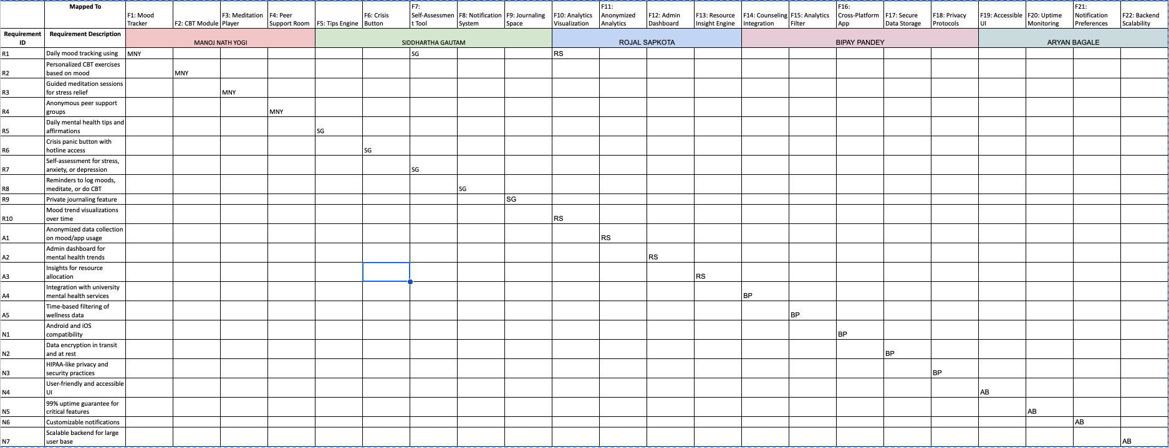
Figure: Complete RTM (Traceability Matrix) chart screenshot

5. Design
The architecture of MindEase is built for scalability, security, cross-platform compatibility, and data-driven insights, ensuring a smooth experience for both students and administrators. The system is composed of four tightly integrated layers:

1. Mobile Frontend (Student Interface)
Developed using React Native, the app delivers a consistent and performant experience across both iOS and Android platforms. React Native allows for code reuse, native UI rendering, and integration of device features like notifications and voice input. The frontend supports:
- Real-time mood-tracking interface
- CBT modules and journaling flows
- Meditation player
- Anonymous chatrooms
- Crisis button and notifications

2. Backend (APIs + Business Logic)
The backend is implemented using Django REST Framework (DRF), a secure and high-performance framework built on Python, chosen for:
- Rapid API development
- Easy integration with machine learning and NLP models (for sentiment analysis, and journaling suggestions)
- Role-based access and scalable architecture
The backend is implemented using Django REST Framework (DRF), a secure and high-performance Python framework.

3. Authentication and Authorization
MindEase leverages Firebase Authentication for:
- Secure user sign-up/log-in using email, phone, or Google OAuth
- Token-based session management
- Role-based access control (students vs admins)
Firebase Auth integrates natively with both mobile platforms and the backend using custom claims and JWTs.
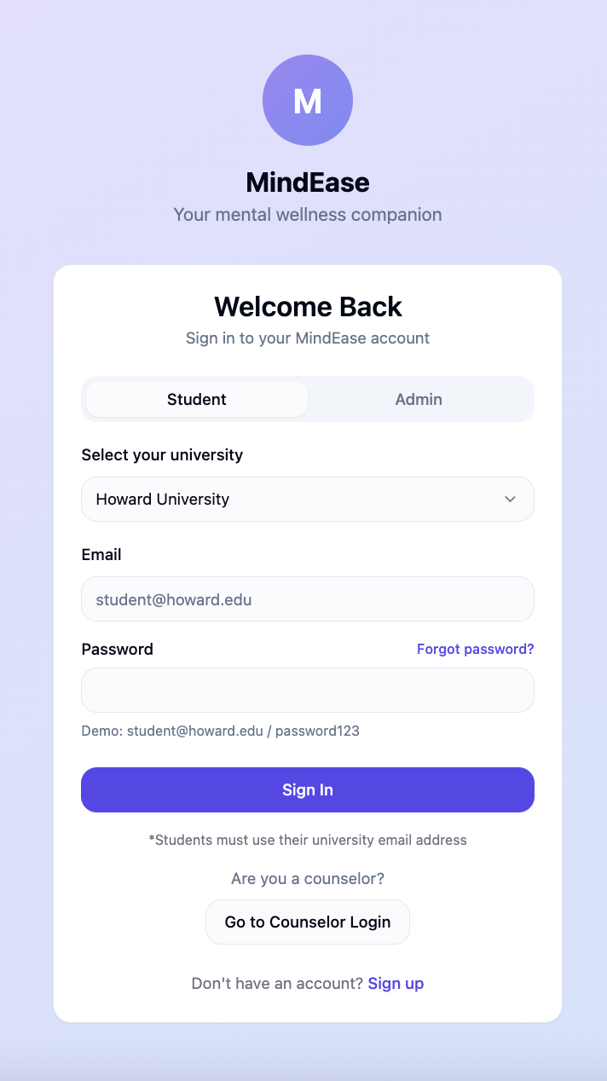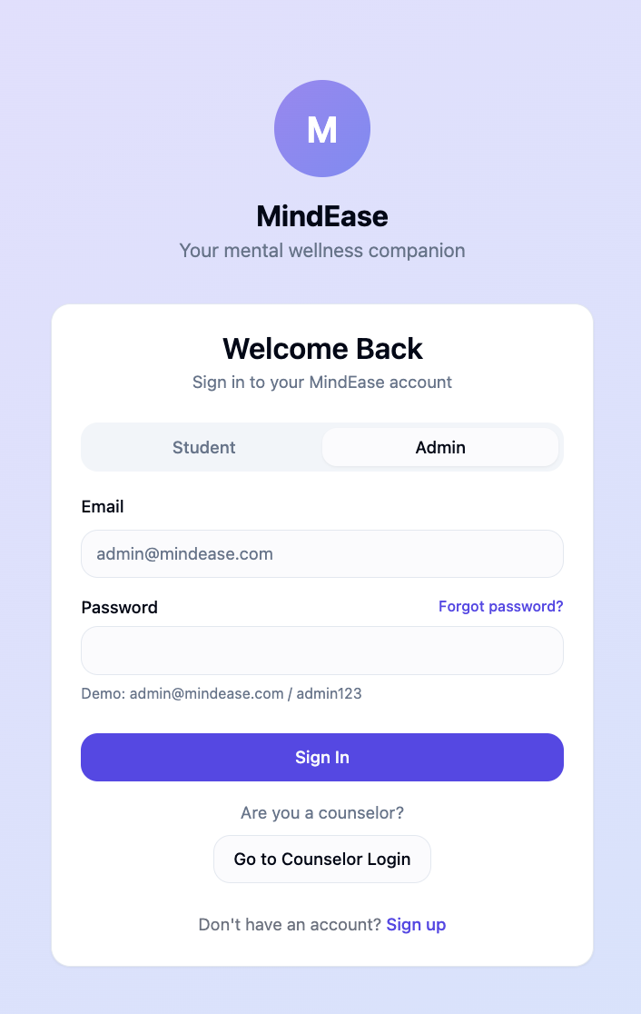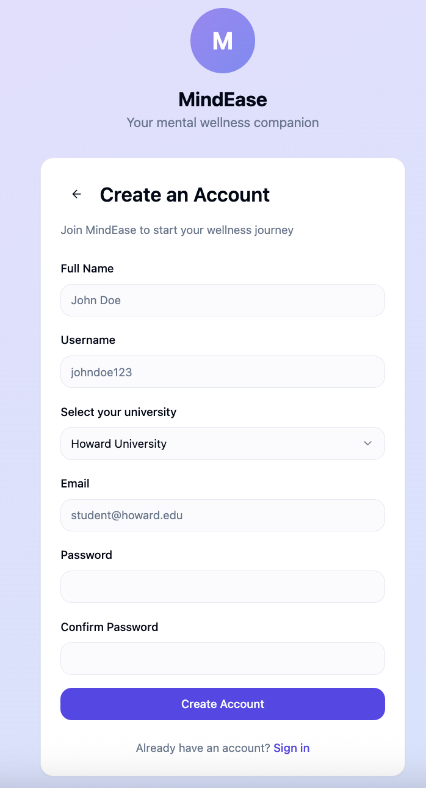

4. Database Layer
MindEase uses a hybrid database architecture:
- Firebase Firestore for real-time, unstructured data like chat messages, mood logs, and notification preferences
- PostgreSQL for structured, relational data like analytics, journaling entries, self-assessment scores, and admin reports
This setup ensures low latency for interactive features and robust analytics support for administrative insight.

5. Admin Dashboard
The admin-facing dashboard is developed using:
- React.js for a dynamic and responsive UI
- Chart.js and Recharts for data visualization
- Protected endpoints with role-based access from the backend
- Data filters (date range, trends, engagement metrics)
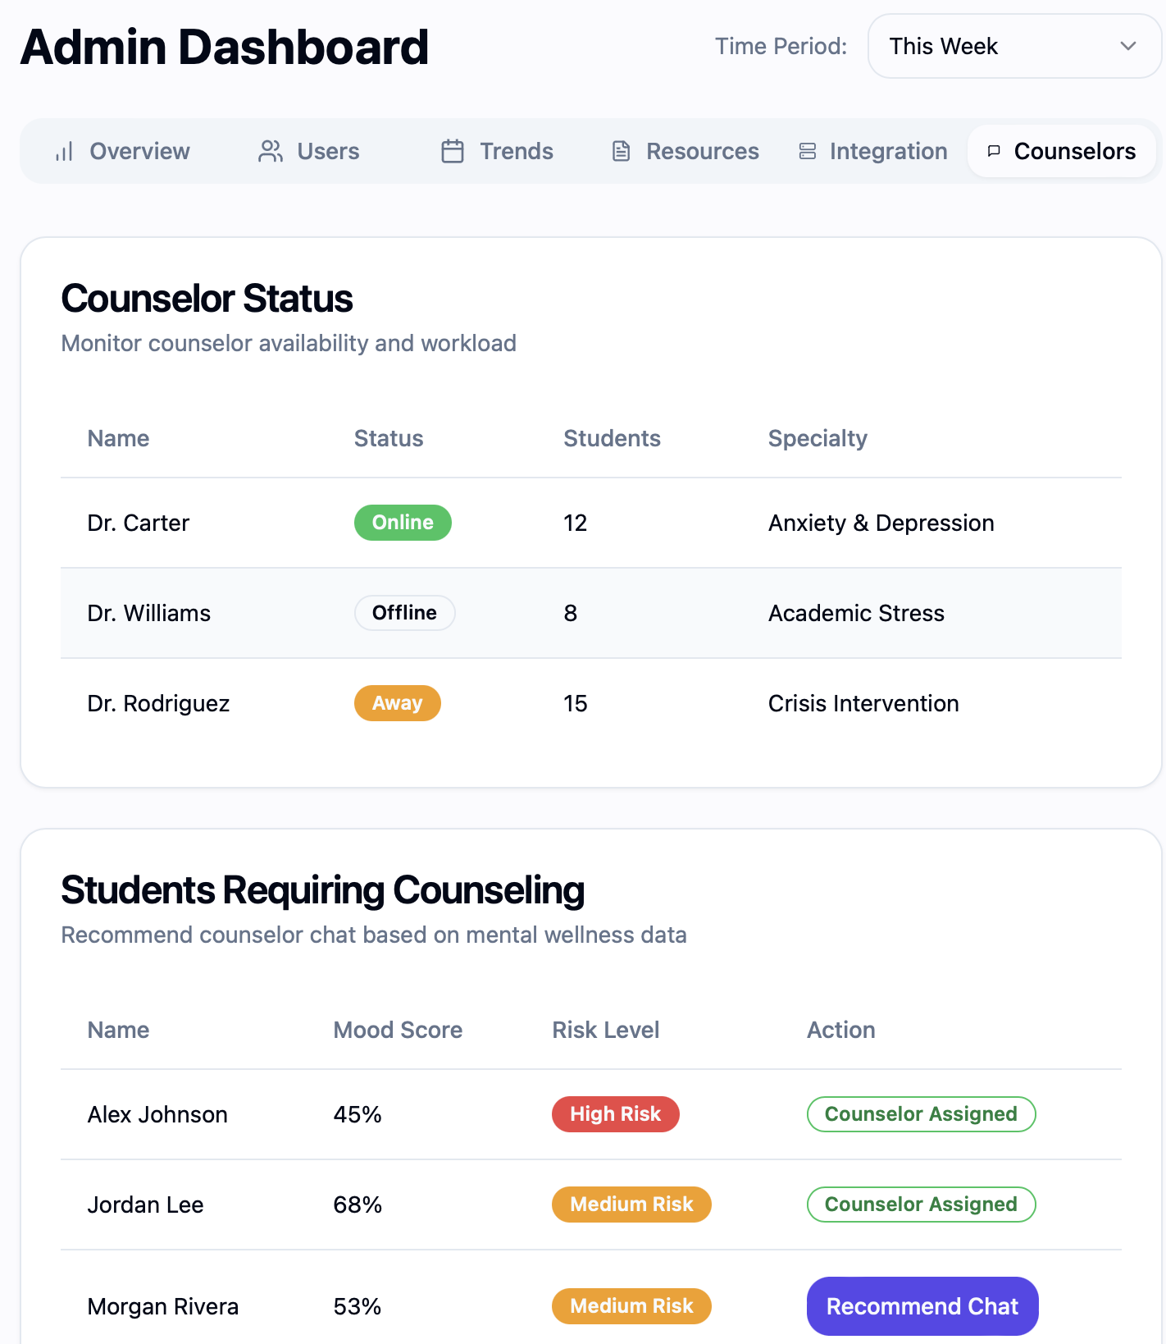
Fig: Admin Dashboard where admin can track the user’s mental wellness status

6. Counselor Dashboard
MindEase also includes specialized features for counselors. The Counselor Portal allows counselors to access student wellness data and engage with students. The Counselor Portal can be accessed using the university email, password, and a Counselor Verification Code, which is provided by the university health center.
- Counselors can view student mood scores and risk levels to prioritize support.
- The Admin Recommendations feature allows the admin to recommend students for counselor chats, and counselors can start a conversation based on these recommendations.
- Counselors can also message students, providing guidance and support in a safe, confidential environment.
This feature empowers counselors to offer more personalized care based on real-time data, promoting early intervention."
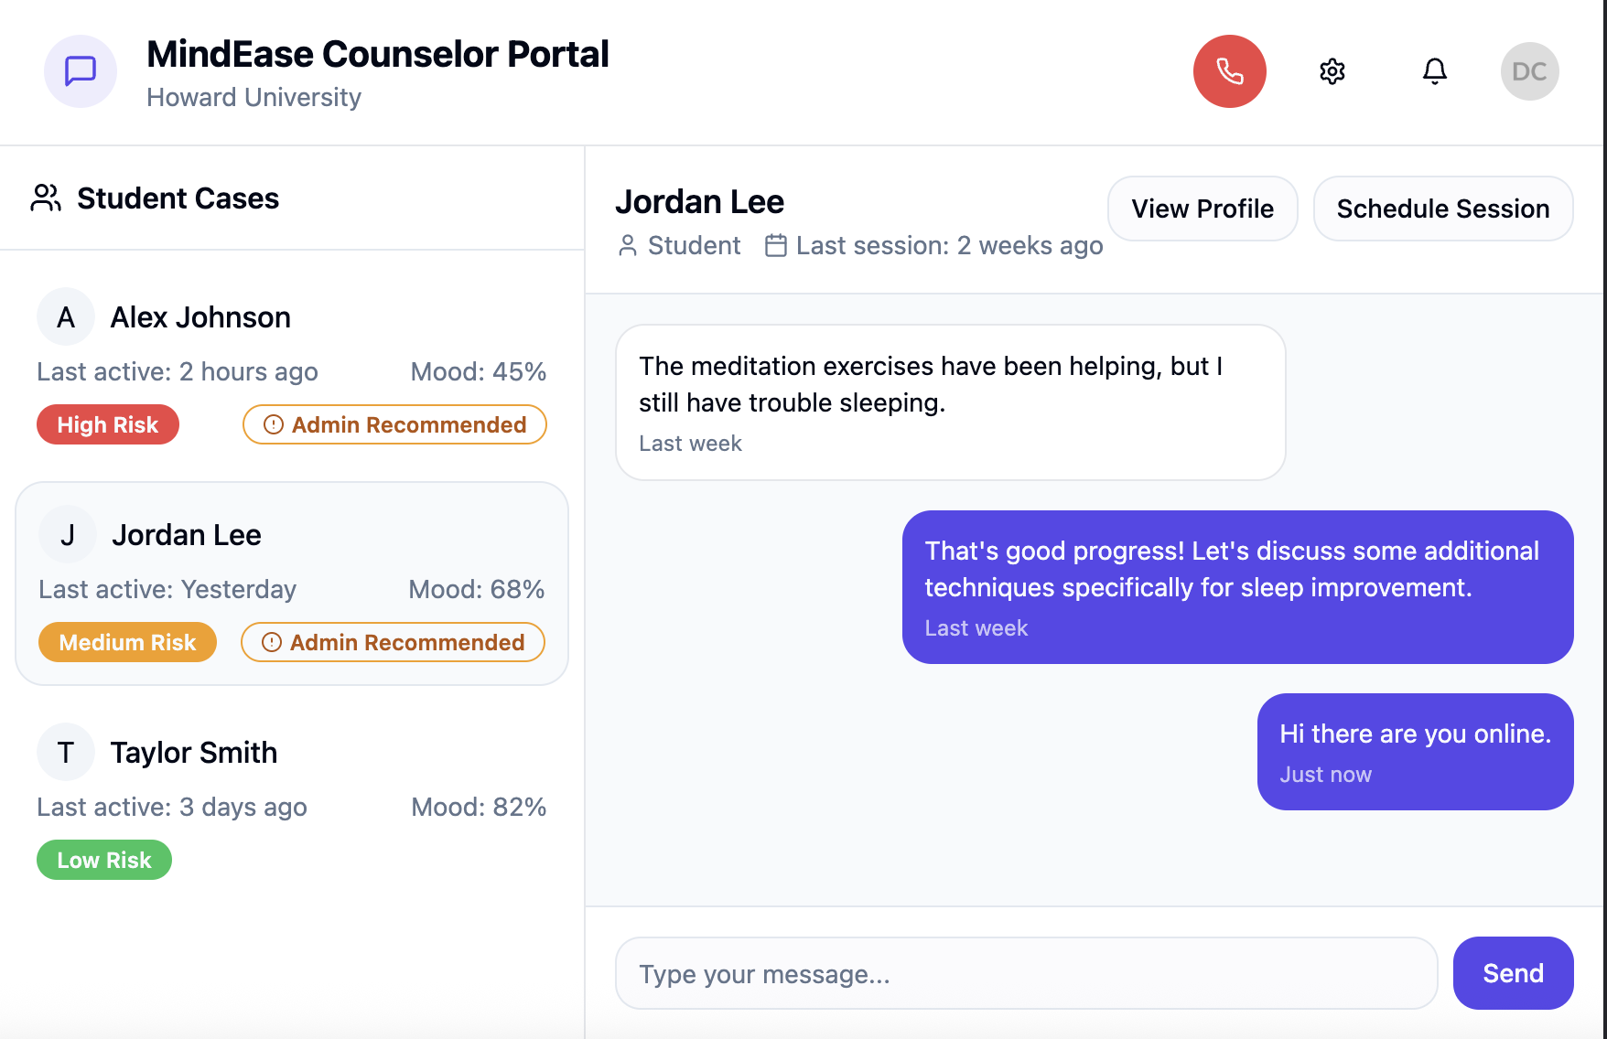
Figure: Counselor page where they can chat with students

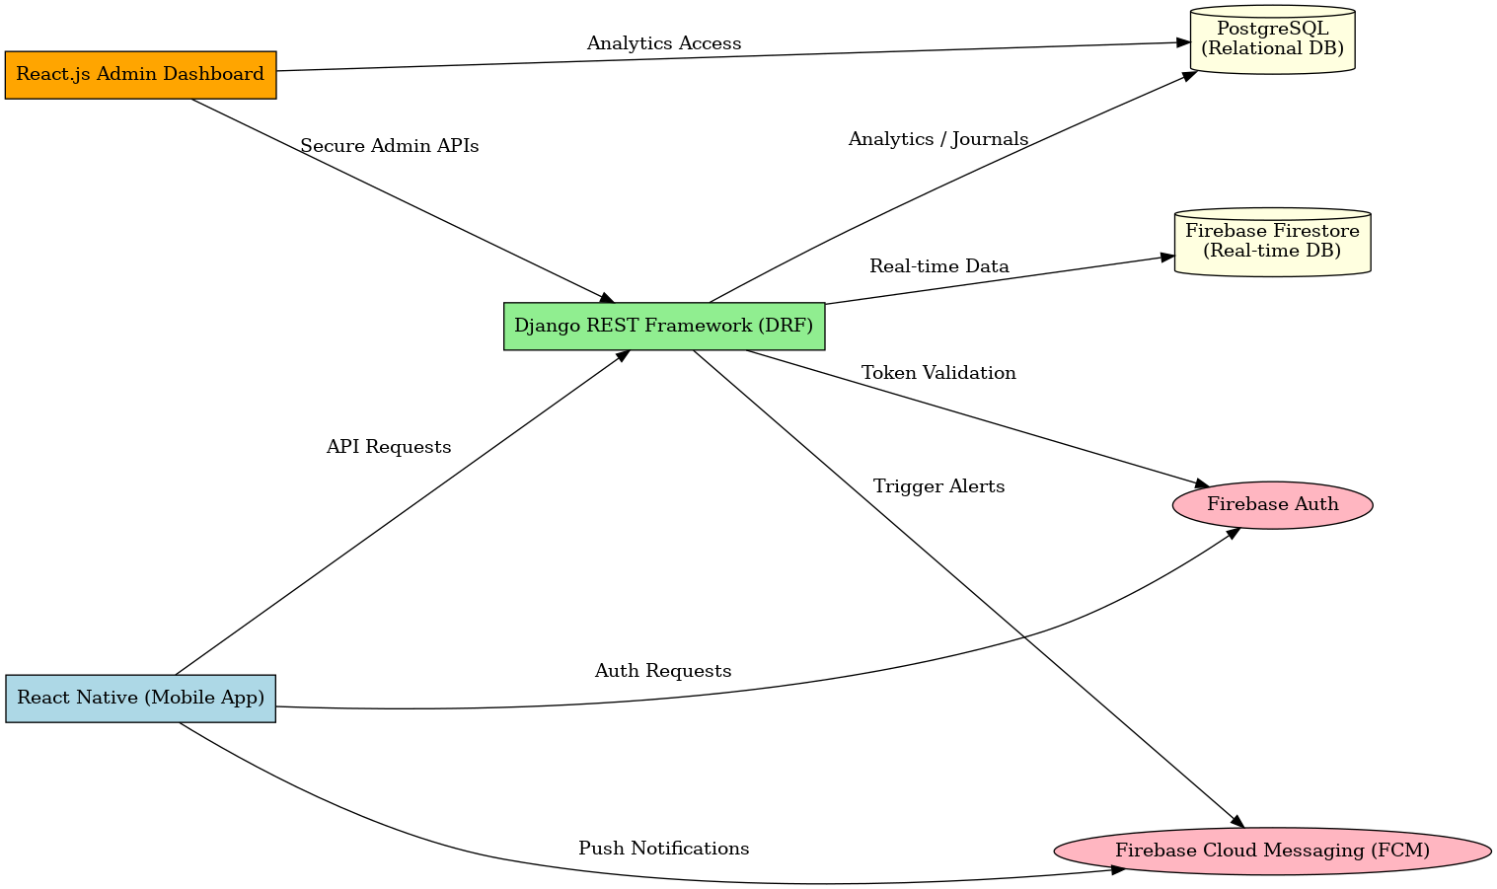
Figure: System Architecture Diagram

6. Technologies
The MindEase tech stack was selected for its scalability, community support, developer familiarity, and native integration with mobile and cloud services. Below is the finalized technology table with rationale:
Layer | Tools/Frameworks | Justification
Frontend | React Native + TypeScript | Cross-platform mobile app development with reusable code and type safety
Backend | Django REST Framework (DRF) | Secure, scalable Python API development, excellent for mental health features & ML integration
Authentication | Firebase Auth | Easy setup, robust identity management, role-based control
Database | Firebase Firestore + PostgreSQL | Real-time sync for chat and logs; relational integrity for analytics and journaling
Notifications | Firebase Cloud Messaging (FCM) | Supports push notifications on iOS/Android with granular targeting
Analytics & Admin UI | Chart.js + Recharts + React.js | Interactive admin dashboard with charts, filtering, and export options
DevOps & Hosting | GitHub (version control), Firebase Hosting (for static files), Heroku (for backend APIs) | CI/CD and scalable deployment with strong support for small teams
Design & Prototyping | Figma | Collaborative UI/UX design with easy export of mockups for documentation and testing

7. Front End
The MindEase mobile application frontend is designed with a focus on user experience (UX), accessibility, and emotional safety. Built using React Native with TypeScript, the front end ensures a responsive, platform-native experience on both iOS and Android devices with minimal code duplication.

Key Characteristics:
- Responsive Design: Auto-adjusts layouts and components to screen size, orientation, and accessibility settings.
- Smooth Transitions: Natural screen animations and loading states enhance user flow without distraction.
- Accessibility Support: Adheres to WCAG 2.1 guidelines including large tap targets, screen reader compatibility, dark/light modes, and font size toggles.
- Emotionally Aware UI: Uses calming color palettes, soft interactions, and non-triggering icons to ensure the mental safety of the user.

Major Screens:
Screen | Purpose
Mood Logging Screen | Users can log their emotional state using emoji sliders, text input, or voice notes. Integrated with real-time sentiment analysis feedback.
Home Dashboard | Central hub showing wellness summary, daily tips, activity prompts, and quick access to other tools.
Meditation Player | Embedded audio player with play/pause, session selector, and animations for guided breathing or focus exercises.
Peer Chat Room | Anonymous group chat interface with topic filters (e.g., “Burnout,” “Exam Stress”), moderation flags, and real-time messaging.

8. Back End
The backend of MindEase is developed using the Django REST Framework (DRF), a robust and secure Python-based framework known for its scalability, maintainability, and seamless API creation. The backend handles the core business logic, securely manages user data, interfaces with databases, and powers both student and administrator experiences. Select Firebase services are integrated to complement real-time features such as chat and notifications.

Core Responsibilities

1. Authentication & Role Management
- User Authentication is managed via Firebase Authentication, supporting secure login/signup with email/password or federated providers like Google.
- Role-Based Access Control (RBAC) is enforced through Firebase custom claims and DRF-based permission classes, ensuring proper access separation between students and administrators.
- Token-based session management is implemented using Firebase ID tokens validated within DRF middleware.

2. RESTful API Endpoints (via DRF)
The backend exposes a set of RESTful APIs to support all frontend functionalities:
- Mood Logs: Submit and retrieve daily mood data, including sentiment labels generated by AI.
- Journals: Securely store, update, and retrieve personal journal entries with optional encryption.
- CBT Modules: Serve personalized CBT tasks and log user completion status.
- Self-Assessments: Collect responses from validated stress/anxiety/depression questionnaires, calculate scores, and provide recommendations.
- Tips & Reminders: Serve daily mental health tips and motivational prompts, optionally personalized based on mood trends.

3. Admin APIs
Dedicated endpoints are provided for administrator functions:
- Retrieve anonymized and aggregated student wellness data.
- Filter trends by date ranges (e.g., during midterms or holidays).
- Generate usage reports and visual analytics for dashboard visualization.

4. Real-Time Features (via Firebase)
While DRF handles all core backend logic, Firebase is integrated for selected real-time features:
- Peer Chatrooms: Built using Firebase Realtime Database, enabling anonymous, moderated real-time group messaging with support for chatroom topics and reporting flags.
- Push Notifications: Delivered through Firebase Cloud Messaging (FCM) for reminders, alerts, and crisis broadcasts.

5. Security & Privacy Controls
- Data Encryption: Sensitive user data (e.g., journals, and assessments) is encrypted using AES encryption at rest, and all data transfers are protected using HTTPS (TLS).
- Data Minimization: Only essential user data is stored, and personal identifiers are never included in analytics logs.
- "Delete My Data" Support: Users can initiate full deletion of their profile and data logs through a secure endpoint, with confirmation workflows.
- Audit Trails: Admin actions and data access events are logged to ensure compliance and traceability.

9. Additional Features
MindEase offers a set of enhancing and differentiating features beyond its core wellness tools, aimed at improving engagement, retention, and actionable insights for both users and administrators.

1. Admin Dashboard
A web-based React.js interface for university health staff to:
- Monitor anonymized mental health trends over time
- Filter reports by semester, event periods, or group cohorts
- View usage rates of mood tracking, journaling, and self-assessments
- Download reports or visual charts for institutional planning

2. Weekly Student Summaries
- Personalized email summaries showing mood trends, recommended activities, and encouragement based on logged patterns
- Option to disable or customize delivery day/time

3. Speech-to-Text Journaling
- Allows students to speak their thoughts directly into the journaling module
- Speech is transcribed using device-native STT tools (or integrated via Web Speech API / Expo modules)
- Especially useful for students with writing difficulties or on-the-go use

4. Event-Based Alerts
- Admins can push system-wide or group-based alerts during high-stress periods (e.g., midterms, holidays)
- Examples:
  - “Take a 5-minute wellness break – guided meditation available”
  - “Reminder: Final exam stress assessment available now”
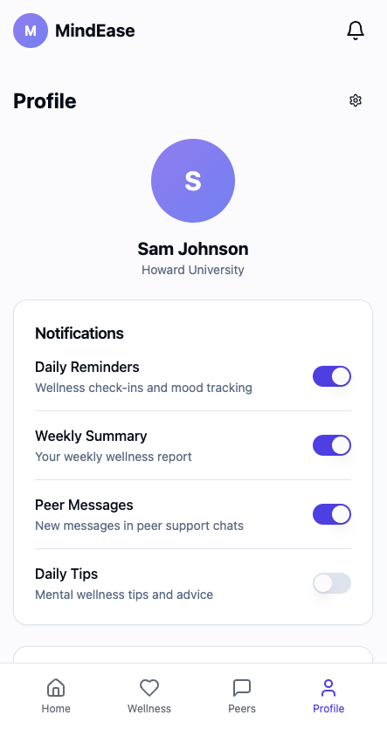
Figure: Notification Preferences Page (toggle interface)

10. Database Design
MindEase adopts a hybrid data architecture using Firebase Firestore for real-time interactions and PostgreSQL for structured analytical data. This dual approach supports both flexible data handling and robust reporting capabilities.

Schema Overview
Collection/Table | Fields | Description
Users | id, name, email, role | Stores authenticated user profiles with role-based access (student/admin)
MoodLogs | userId, moodScore, textInput, timestamp, sentimentLabel | Daily emotional states logged by students, integrated with AI-based sentiment detection
CBT | userId, moduleId, completed, completionDate | Tracks personalized CBT exercises completed by users
Journals | userId, entryText, tag, timestamp, isEncrypted | Stores user reflections with optional tags and encryption flags
Chats | roomId, messages[], senderId, timestamp | Peer chatroom data with message logs, anonymous IDs, and moderation flags
Notifications | userId, type, frequency, time, enabled | Store notification preferences and delivery schedule
Assessments | userId, assessmentType, score, responseData, timestamp | Stores quiz responses related to stress, anxiety, and depression
AdminStats | date, moodSummary, usageCounts, engagementRate | Aggregated, anonymized analytics for administrator dashboards

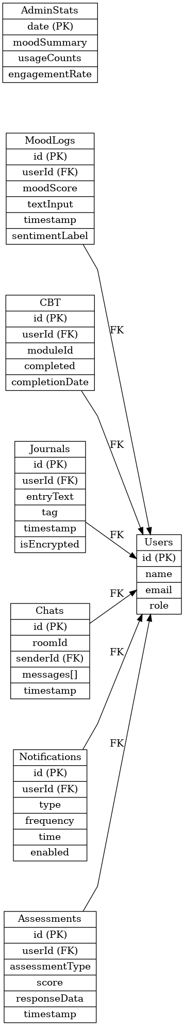
Figure: ER Diagram

Security Considerations:
- Encrypted journal entries (isEncrypted = true)
- Role-based query access (e.g., Users.role === "admin" for AdminStats)
- Indexed fields for efficient analytics filtering (e.g., by date or moodScore range)

11. User Interface (Mock-ups)
The UI/UX design of MindEase is centered around simplicity, emotional safety, and accessibility. All key flows are mobile-first and have been prototyped using Figma.
Required Screens to Include (attach as images):
Screen | Description
Login/Signup | Simple email/OTP login screen with branding and role selection
Mood Tracker | Emoji slider, text/voice input, and AI-sentiment feedback panel
CBT Suggestions | Personalized CBT dashboard showing exercise cards based on mood
Meditation UI | Audio player with categorized session library (e.g., "Sleep," "Calm")
Crisis Button Modal | Red panic button with confirmation dialog and hotline list
Admin Dashboard | Card-style layout showing student engagement, wellness stats, and filtering
Notification Preferences | Toggle-based interface to enable/disable reminders with time selection

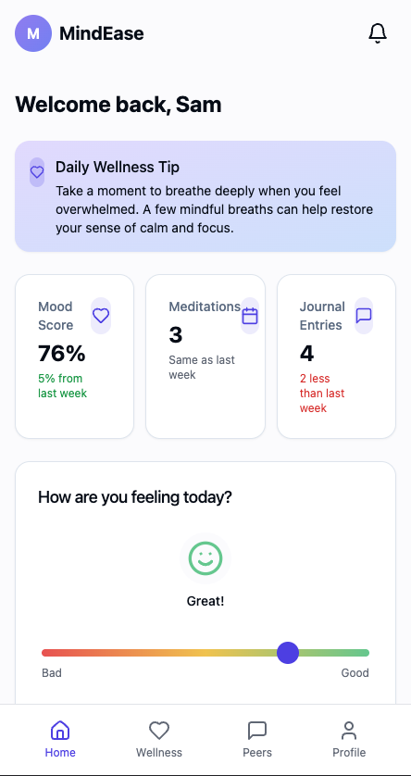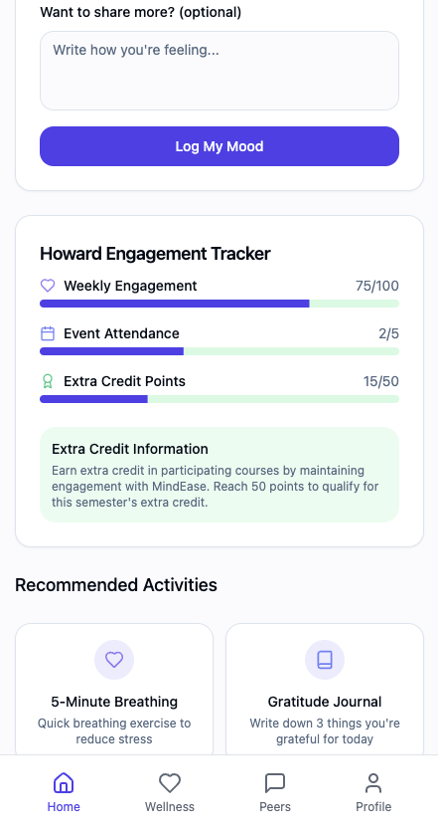
Figure: Home Page of the Student
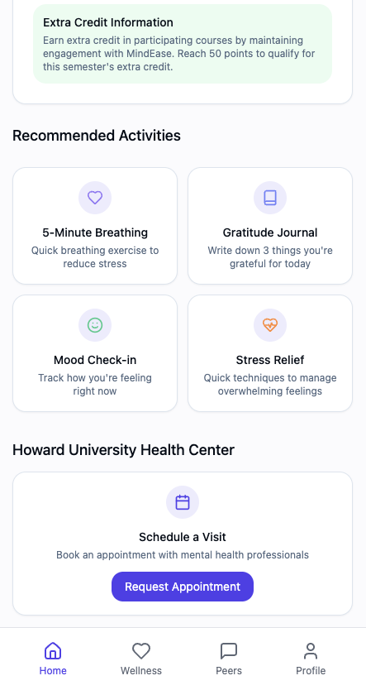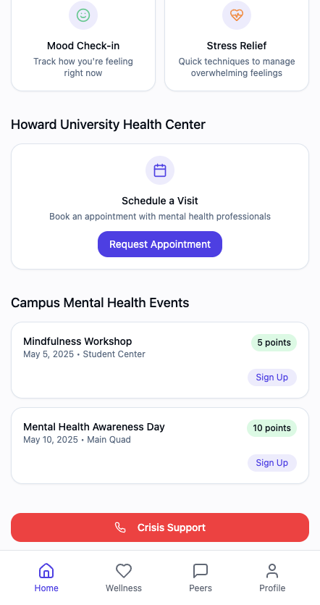
Figure: Home Page of the Student
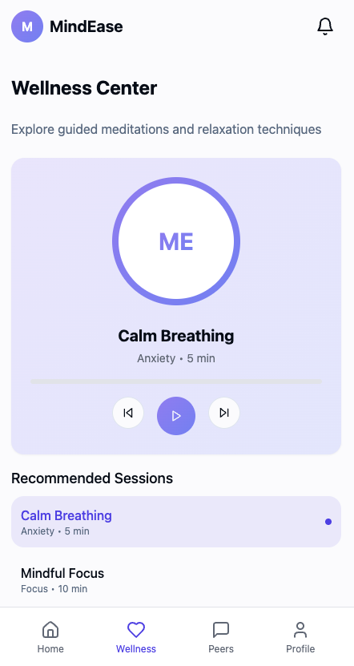
Figure: Students can visit the wellness page and access the different techniques for mental wellness
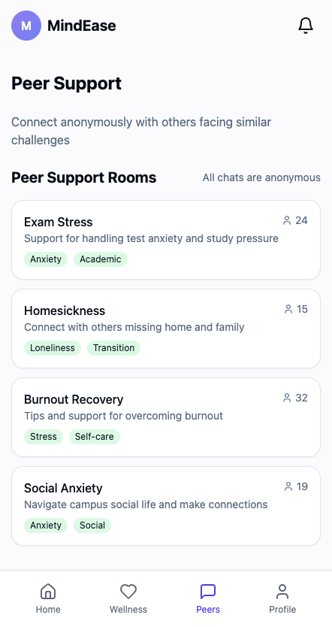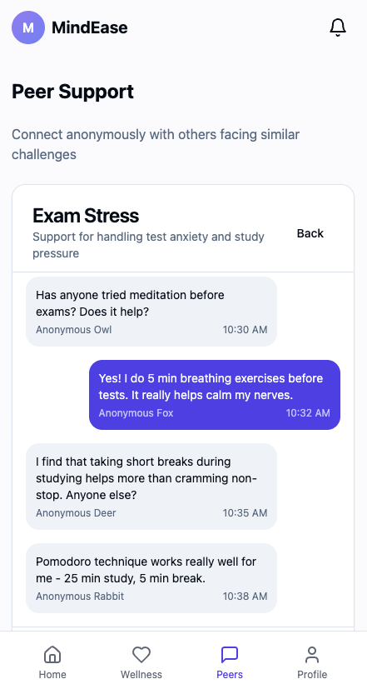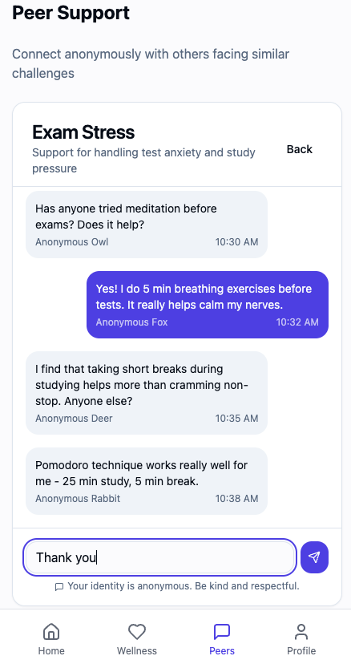
Figures: The Peer support section where Students can see the groups, join the group anonymously, and chat.
Figure: Profile Section where Students can manage their preferences

12. Test Strategy and Test Plan
The testing plan for MindEase follows Agile development best practices, combining automated and manual tests to ensure feature correctness, security, performance, and accessibility.

12.1 Testing Types
Test Type | Scope | Goal
Unit Testing | Individual components and logic (e.g., mood score calculation, input validators) | Ensure that modules function in isolation
Integration Testing | Interaction between frontend and backend APIs | Validate data flow and consistency between services
System Testing | Test the entire integrated system, including frontend, backend, auth, database, and notifications working together as a whole | Ensure that all components function correctly and meet system-level requirements.
End-to-End (E2E) Testing | Full user journeys (e.g., login → mood log → dashboard update) | Simulate real-world scenarios and identify edge cases
Security Testing | Auth and access control, data encryption validation | Ensure PII protection and restrict access appropriately
Accessibility Testing | UI/UX testing using screen readers, contrast checkers, keyboard navigation | Ensure compliance with WCAG 2.1 standards
Acceptance testing | Verify that the system meets all functional, non-functional, and user-specific requirements based on the RTM and stakeholder expectations. | Validate system readiness for release by confirming user stories and project objectives are fulfilled.

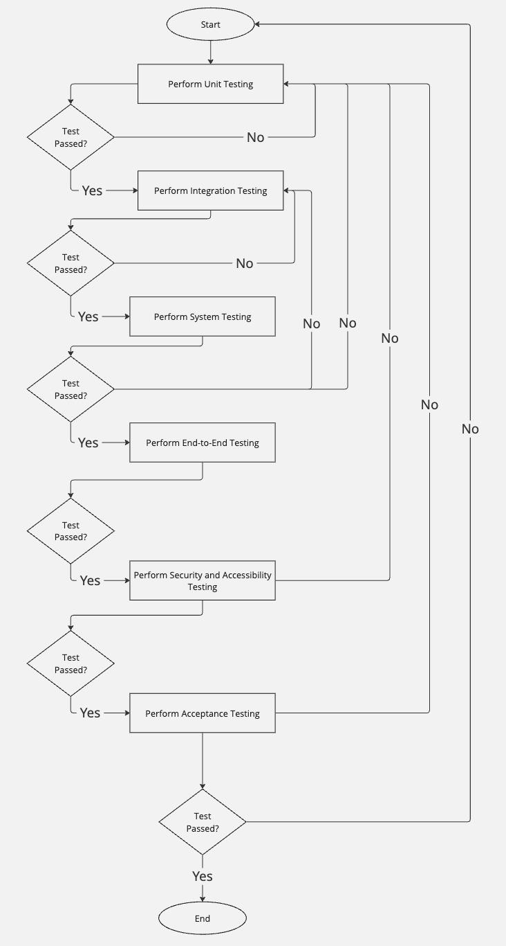
Figure: Testing planing

12.2 Testing Tools
Tool | Purpose
Jest | Unit testing for React Native components
Postman + Pytest | API endpoint testing for DRF backend
Cypress or Detox | Full-stack automated E2E testing
Lighthouse / Axe DevTools | Accessibility audits and performance scoring
Expo Test Tools | Device/emulator testing for React Native features (e.g., push notifications, voice input)

Sample Test Case Table
Test ID | Scenario | Input | Expected Output | Result
TC01 | Login with a valid university email | test@student.edu | Redirect to dashboard
TC02 | Submit mood with slider + text | Sad, "feeling overwhelmed" | Stored + sentiment = negative
TC03 | Attempt admin access as a student | Token (role: student) | 403 Forbidden
TC04 | View the dashboard with no logs | New user | Show “No data yet” message
TC05 | Voice input journal | Audio clip | Convert to text + save entry
TC06 | Dark mode toggle | Enabled | UI theme updates

13. References
- Firebase Documentation – https://firebase.google.com/docs
- React Native Docs – https://reactnative.dev
- Django REST Framework – https://www.django-rest-framework.org/
- Figma – https://www.figma.com
- OpenAI GPT (used for sentiment analysis) – https://platform.openai.com
- NAMI College Guide – https://www.nami.org
- WCAG Guidelines – https://www.w3.org/WAI/WCAG21/quickref/
- RTM: https://docs.google.com/spreadsheets/d/1lcQiLo_tCGJaUqUQyNdyxkFgp6OfJEhwXTLKt2jUEZ8/edit?usp=sharing
- Decomposition of the Features: https://docs.google.com/document/d/1W1M6Lpevojdnwwa_1MvczX3o2cRqVpOuhx2tbQfJMrw/edit?usp=sharing
- Student mental health is in crisis. Campuses are rethinking their approach, https://www.apa.org/monitor/2022/10/mental-health-campus-care
- Mininsohn, S. (2025, January 27). College Student Mental Health Statistics - 2024. College Transitions. https://www.collegetransitions.com/blog/college-students-mental-health-statistics/
- User Interface mockup and FIgma, https://preview--spec-sheet-delight.lovable.app/

